Computer Theory 1

Computers manipulate data according to pre-set instructions. The cycle of activity of a computer is as follows.

**Input-** Accepts data from things such as clicks, keys, touch screen.

**Processing-** “Buzz”. Reads data, performs calculations. Manipulates data.

**Output-** The final output; the computer presents data after processing.

Computer Ware

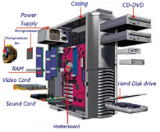

**Hardware**- Physical components of a computer. Mouse, keys

**Software**- Programs (set of step by step instructions for the computer).

**Operating system**- Organizes and stores the computers software (Windows XP, Windows 7, iOs, DOS).

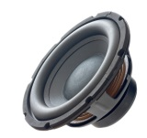

**Output devices**- Printer, speaker, screen, touchscreen

**Input Devices**- Keyboard, mouse, scanner, touchscreen, DVD, microphone, camera.

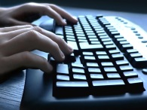

(Some devices are able to output as well as input information. For example, a touchscreen can get input information by touching the screen while display the output as well).

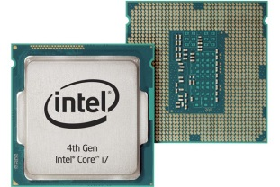

Sub Units of the Central Processing Unit (CPU)

-**The Arithmetic logic** **Unit** performs calculations and makes decisions.

-**The Control unit** directs instructions into and out of a computer.

-**The Storage Unit** stores programs and data.

Once the information is processed, the computer presents the information back to you.

**Soft copy**- A computerised document.

**Hard copy**- A printed document.

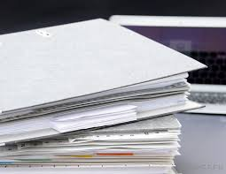

Buying a Computer

The two popular criteria to consider when buying a computer are

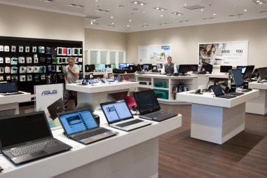

-Price

-Size (memory, power and speed).

These criteria also help define or classify a computer

Types of Computers

-Mainframes (Maxi-computers)

-Mini Computers

-Micro computers

-Portable computers

-Handheld computers

**Mainframes**

These computers are used by people such as the government, weather bureau, armed forces, police department, NASA and TSE.

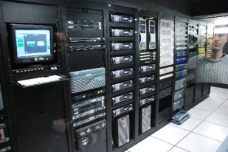

These computers have a huge memory capacity and very fast processing speeds. This is the most powerful and most expensive type of system.

**Minicomputers**

Used by large co-operations such as the BAY, TDSB and the Canadian Tire.

**Microcomputers**

This sort of computer is used in Schools, small business, and at home for personal use (PC). This computer generally does not need special wiring like other computers. Microcomputers may also be networked, and are affordable for most.

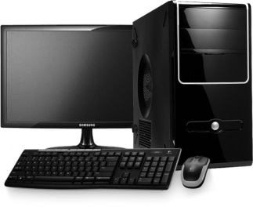

**Portable Computers**

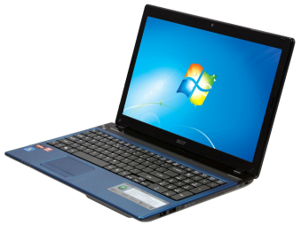

Portable computers were initially used by travelling business people and by University and college students. It is used very often due to very affordable costs. Portable computers include laptops, notebook computers and tablets.

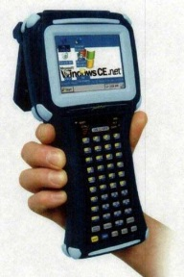

**Handheld Computers**

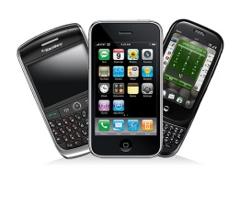

Handheld computers are very small devices making it very easily portable. Used very often as a PIM (Personal Information Manager).

Using your Computer

All computers today have the capacity of becoming sophisticated. All computers are adequate but the application should determine the choice of computer needed.